

Custom Topics and Tags Guide

Permissions
Permission Set Name | Object Permissions | Custom Metadata Permissions
Topic Admin | Topic__c (Read, Create, Edit, Delete, View All, Modify All) | Topic_Configuration_mdt (Read, Create, Edit, Delete)
Topic User | Topic__c (Read, View All)  Topic_Junction__c (Read, Create, Edit, Delete)

Customization Guide

- Go to Object Manager > Topic and add a desired category to the Category picklist field.

- Create Topic Configuration Metadata Records with the following required and optional fields. This will determine which Topic Categories will be available to use on each object.

Required:
  - Label
  - Topic Configuration Name
  - Category
  - Object Visibility
  - Icon Name

Optional:
- Object Field
- Pill Color
- Pill Style

Note: If you would like to map Topics to a specific field on an Object, create a new multi-select picklist field on respective Object, and then reference the field in Object Field in the metadata record. In this example, we have created a metadata record to display Utilities Topics on the custom Utilities field on Account object.
Important: Make sure to uncheck Restrict picklist to the values defined in the value set when creating the multi-select picklist.

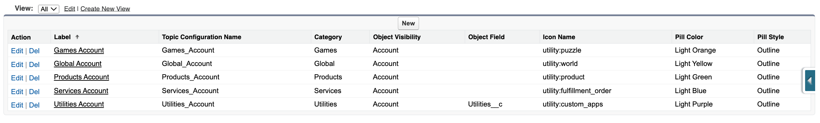

Figure 2: Sample Topic Configuration Metadata records. In this example, these Topics will be available to use on Account record.

- Drag-and-drop topicCardComponent onto lightning Record Detail Page and fill out the required fields:
  - Card Title
  - Card Icon
  - Card Help Text
  - Object API Name
  - Topic Categories – a comma-separated list of Categories that will be visible to users on this lightning page

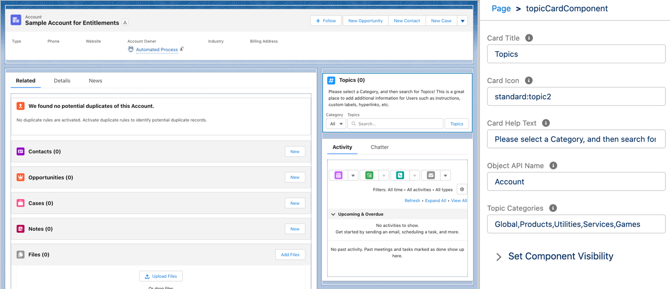

Figure 3: Sample Record Detail Page. Component has been placed in upper corner of right column. Required fields are visible in editor.

- Create Topic records with required fields:

  - Topic Name
  - Category
  - Object Visibility
Note: You can set the Topic to only be active during a period of time by setting Start Date and End Date.

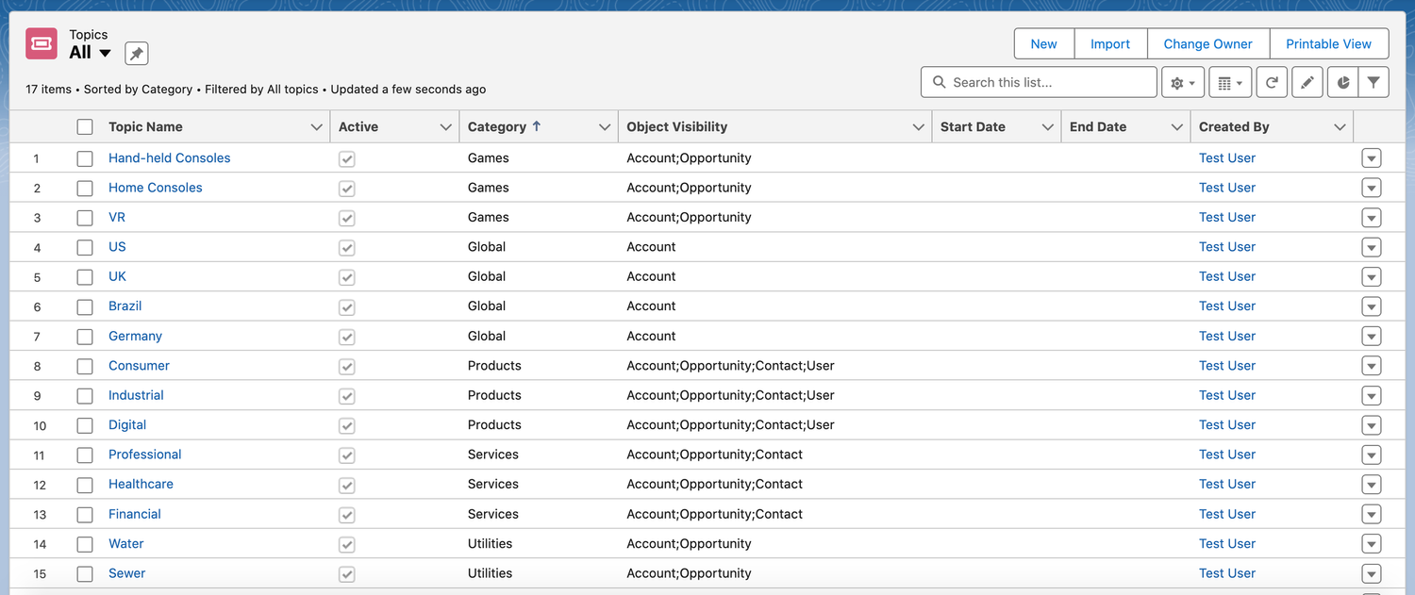

Figure 4: Sample Topics list view. In this example, Home Consoles is a Games Topic that will be visible on Accounts and Opportunities. US, UK, Brazil, and Germany are Global Topics that will be visible on Accounts.

- Go to Object record, such as an Account, and locate the topicCardComponent. In the Category dropdown, select a specific category or keep as All.

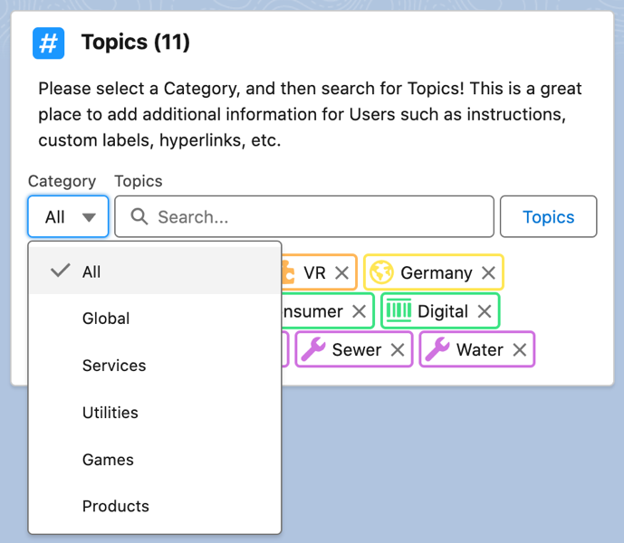

Figure 5: Sample Category dropdown list.

- In the search input, start typing the label of a Topic. You will see a list of Topics matching the search value in a dropdown list.

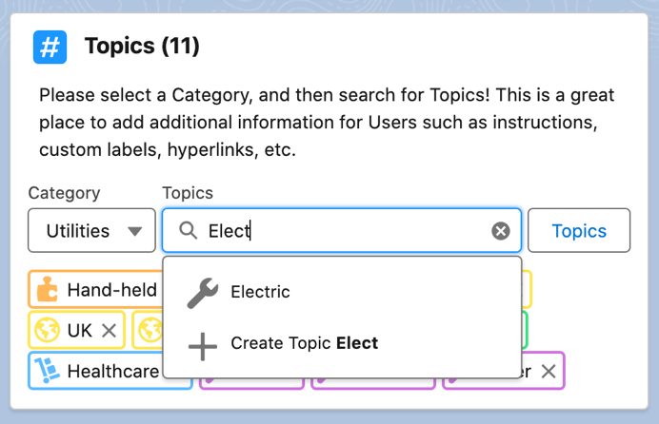

Figure 6: Sample input with search results.

- Select a Topic from dropdown list by clicking on the specific row. The selected Topic will be added as a pill in a pill container below the search input. The pill color and pill style are determined by the respective custom metadata record that was set in Step 1. If you have opted to map a specific Topic Category to a specific field in Step 1, the Topic will be added to the specified multi-select picklist and the picklist value will be automatically activated on picklist field.

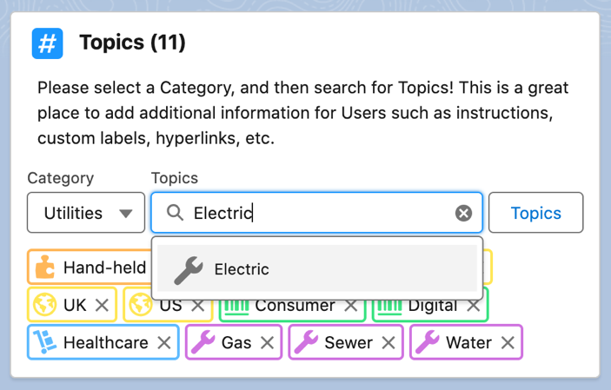

Figure 7: Sample search input with highlighted Topic.

Note: You can also create a new Topic using the topicCardComponent. Start typing the name of a new Topic that you would like to create. At the bottom of the dropdown, you will see a + and the name of the new Topic in bold. Clicking this row in the dropdown will take you to the standard Topic record create page. Fill out the details and click Save to create a new Topic.

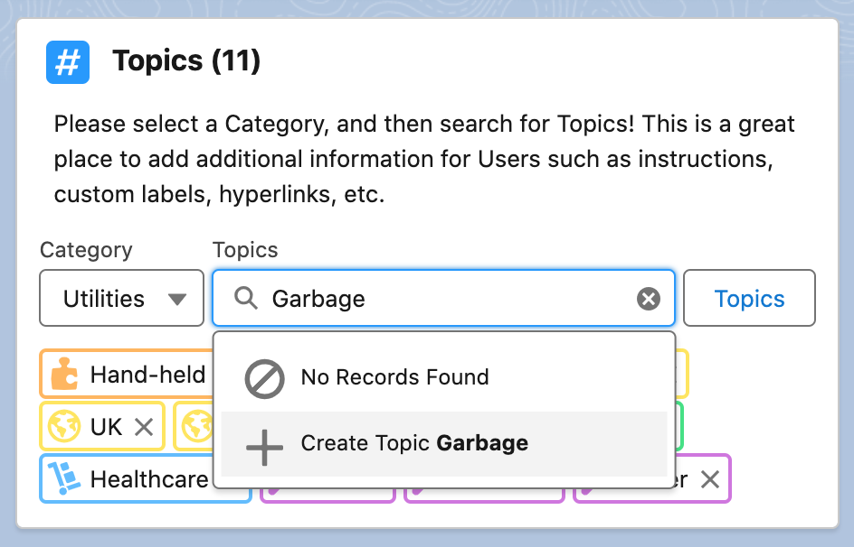

Figure 8: Sample search results with no matching Topics. User is highlighting option to create new Topic directly from the component.

